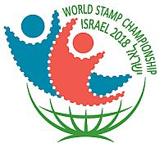
ISRAEL 2018

WORLD STAMP EXHIBITION CHAMPIONSHIP
27/5/2018 - 31/5/2018

PHILATELIC LITERATURE EXHIBIT INFORMATION FORM

Author(s) :

Exhibitor(s) :
[If differs from Author(s)]

Title of exhibit :

Publisher / where to order :

Year of publishing (of current edition) :
Which edition (1st, 2nd or 3rd etc.)

Number of pages :

Format (..mm x ..mm) :

Frequency of publication :
(Periodicals only)

Price :

ISBN :

Quantity Printed :

Brief description :
(Up to 50 words)

Contents: (to attach a copy of contents page, preferably in English, in addition to the published language)
Additional information: such as Preface, introductory page etc. would be useful.

